ITECH2003:Web Design Document

|  |  |
| --- | --- |
| **STUDENT NAME:Huaye Zhang** | **STUDENT ID: 30395655** |
| **TUTOR NAME:Grant Meredith** | |

**Contents**

ITECH2003: Web Design Document1

Contents.......................................................................................................................1

1. Overview...................................................................................................................2

1.1. Description.........................................................................................................2

1.2. Highlight.............................................................................................................2

1.3. Target Audience................................................................................................2

2. Site Content & Structure...........................................................................................3

2.1. Navigation Scheme............................................................................................3

2.2. Content Inventory..............................................................................................4

3. Content Design..........................................................................................................5

3.1. Page Layout.......................................................................................................5

3.2. Wireframes.........................................................................................................5

4. Visual design.............................................................................................................9

4.1. Home Page Mock-Up.........................................................................................9

4.2. Colour Scheme...................................................................................................10

4.3. Typography.........................................................................................................10

5. References.................................................................................................................10

1. Overview

1.1. Description

The name of the page is: Dream of Becoming a Lawyer.A lawyer is a qualified lawyer who has the obligation to uphold the law and protect the rights of his clients. Lawyers help uphold the basic part of the law, which is the Constitution. Lawyers are of fundamental importance to national judicial administration in various ways.Some of the duties of a lawyer include:

Provide legal advice and counsel；

To study and gather information or evidence；

Drafting legal documents related to divorce, wills, contracts and some transactions；

To assist a litigant in his prosecution or defense in court.

As a lawyer, I will devote myself to the pursuit of fairness and justice, and safeguard the authority of the law and the legitimate rights and interests of the parties.My career dream is to be a lawyer in the People's Republic of China, including my learning experience and contact information.

The first interface introduces my dream career to be a lawyer, and my declaration of this sacred career;

In the second interface, I introduced my work experience, described my experience, and I also provided some pictures；

The third interface introduces my professional skills；

The fourth interface is my contact information, address and company;

The fifth interface is a few customer comments about my work；

The sixth interface is the professionalism of my work；

The seventh page shows some of the articles I've published.

1.2. Highlights

1. Use the mouse to hover and change the background color and text color of the navigation link to remind users of the current status, which is more concise.

2. Eight different categories of links are provided, no level classification is required. All the pages are on the same level, and the navigation is on the left side of the site, highlighting some of the site's features

3. flexible layout (flex layout) is used, which is very convenient. I can control the layout of the div as much as I want and it doesn't affect the logic of the grid layout and secondly, the layout is very responsive. I used a font size control of vw+rem, which works well with this reactive design having 375px and 800px breakpoints.

1.3. Target Audience

For the profession of lawyer, the target audience is the people who need to be provided with legal services, which can be divided into the following categories:

1. People with enough money

2. People with complex legal relationships whose cases are being litigated

3. Cases where the application of certain laws is difficult and controversial

4. Cases in which the parties have difficulty obtaining evidence

By tagging and categorizing contacts based on these metrics, you should be able to get some basic understanding of the people on your list and how well they fit into the company's desired goals. It also allows you to see if your audience is predominantly made up of any one or more groups, such as business owners, individuals, company executives, men, women, etc.

To sum up, in the above cases, the parties are the main audience of lawyers, and the intervention of lawyers can help the parties better safeguard their legitimate rights and interests.

# Site Content & Structure

2.1. Content Inventory

|  |  |  |
| --- | --- | --- |
| Page | content type | label |
| * All Pages | Image  Text hyperlink | My avatar  my profession  web page link:expeince,criminal law,  Contact me ,essay,tourism,appraise,specialized,home, |
| Experience | Image  Text | Pictures of my experience  Describe my experience |
| Contact Page | Image  Text  The submit button  Input box  The submit button | My professional picture,  My information card  Convert from to obtain user information  User input Information  User submits form |
| Essay | Text | * My Photo |
| Specialized | Text  statistical chart | My professional skills  My skill ratio |
| Appraise | The picture  Text,  The text  Input box | User submitted pictures  Text submitted by the user  The user's own signature  Provide input to the user |
| Criminal law | Picture  Text  Picture | The cover of a criminal law book  The content of criminal law,  Pictures of criminal law |
| Tourism | Picture  Text | The wheel cast pictures of the trip,  An introduction to pictures |

2.2. Navigation Scheme

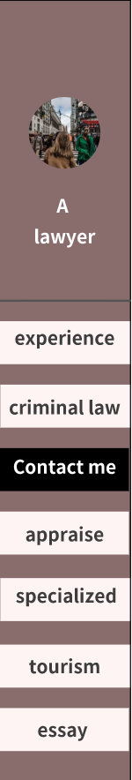

In my fixed navigation bar, the navigation logic is to introduce the website page to users intuitively in words, so as to establish a strict and sincere image of a lawyer,

Use hover and change the background color and text color of the navigation link to remind the user of the current status, eliminating the complexity of removing bread crumbs

As shown in the navigation map, eight different categories of links are provided, so no level classification is required. All pages belong to the same level,at the same time, the navigation is located on the left side of the website, which can highlight certain functionality of the website, so as to deepen users' impression of my status as a lawyer. This is exactly the purpose of my design.

# Content Design

3.1. Page Layout

Because I need the website to be responsive and adaptable (which is very difficult), I have adopted the flex layout (flexible layout), which is very convenient. I can control the layout of divs at will It does not affect the logic of grid layout Next, the responsive design of this layout is very good. I use the font size control of vw+rem, which can work well with this responsive design

There are 375px and 800px breakpoints. I think this is enough at this stage.

3.2. Wireframes

criminal law

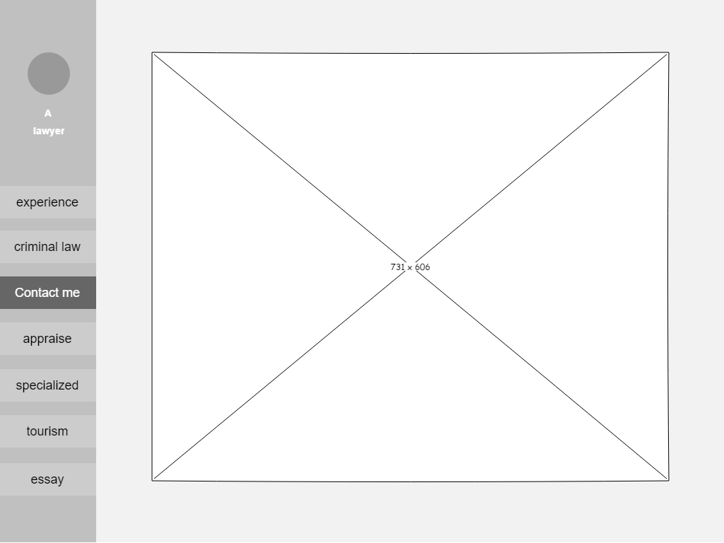

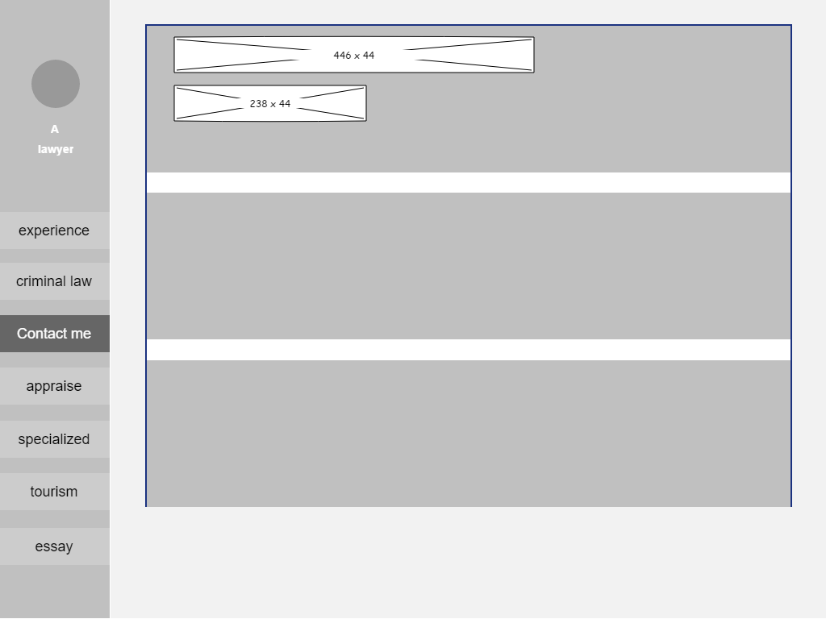

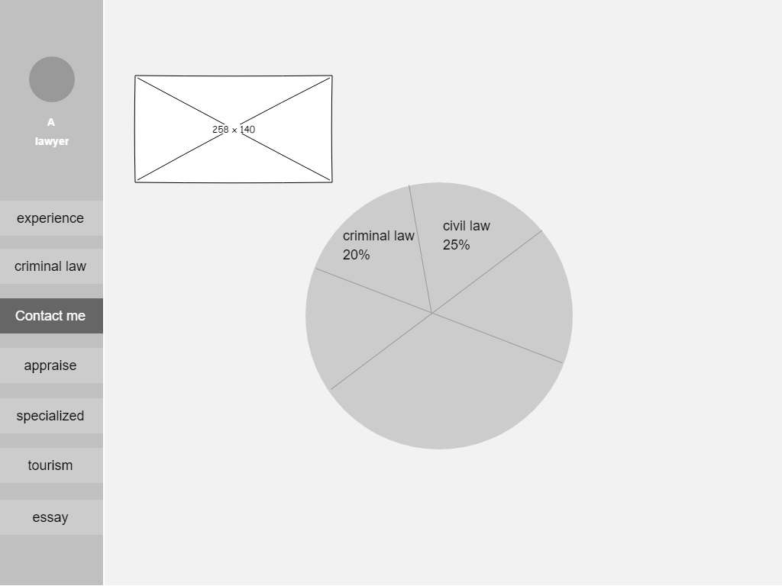

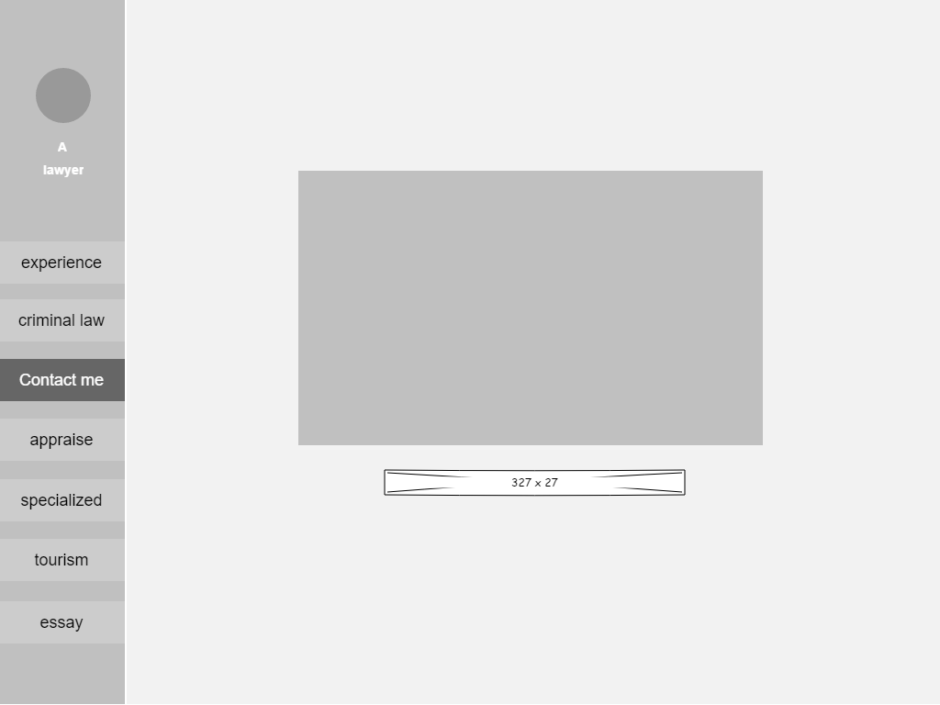

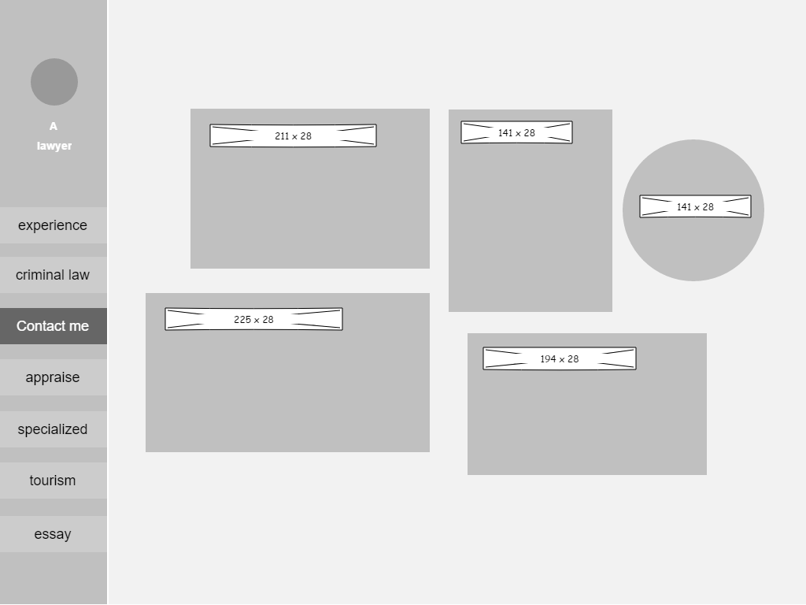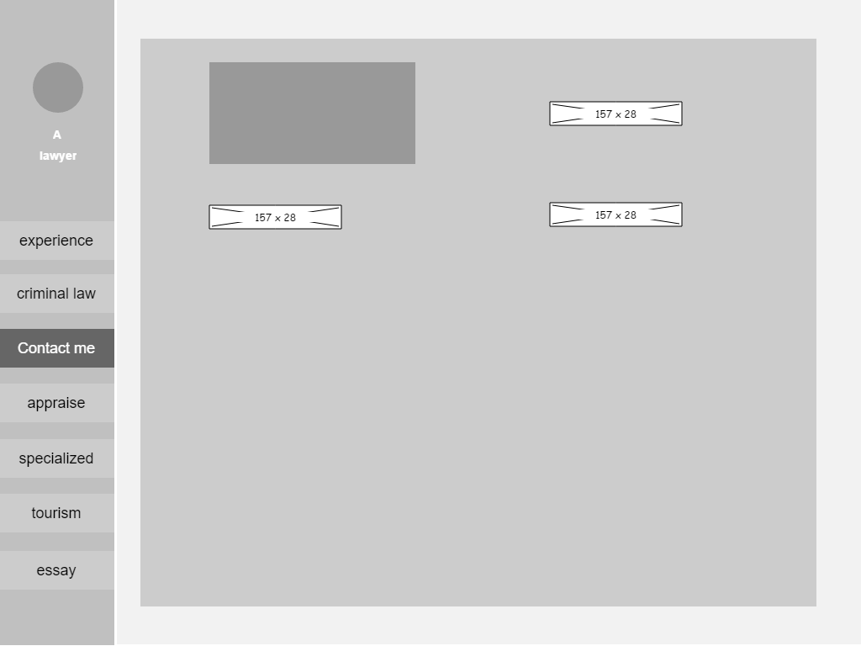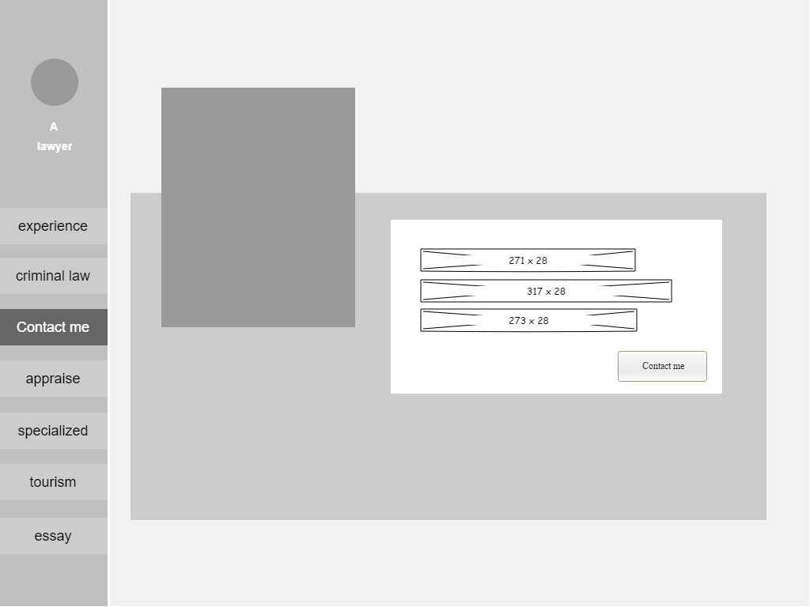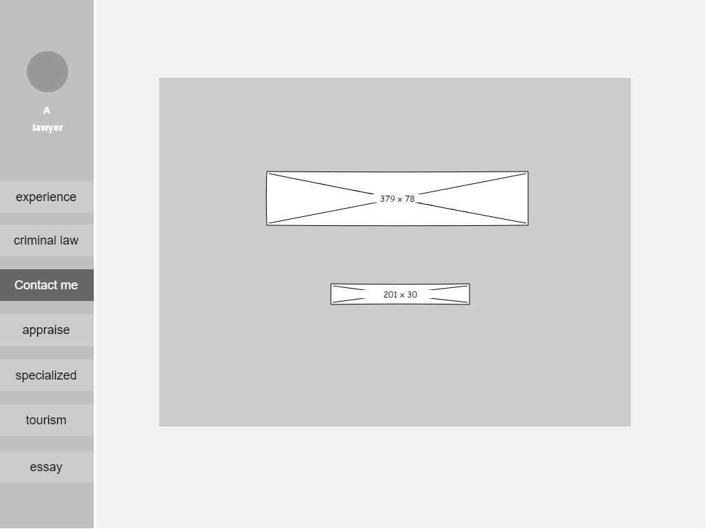

# Visual design

# 4.1. Home Page Mock-Up

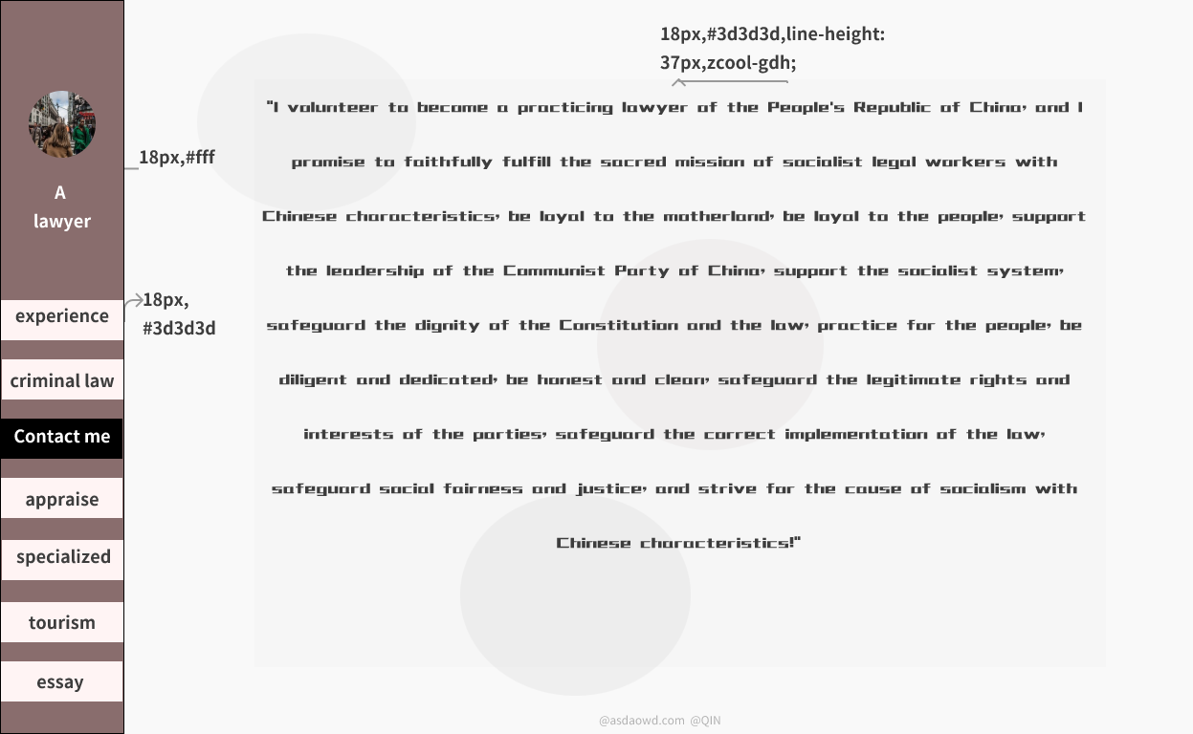

4.2. Colour Scheme

tourism

|  |  |  |
| --- | --- | --- |
| #896d6d |  | Stable and neutral |
| #fff4f4 |  | On behalf of my gentleness |
| #ffff |  | Serious, contrast with white |
| #0000 |  | Justice, in contrast to black |

4.3. Typography

|  |  |  |  |
| --- | --- | --- | --- |
| Navigation | Source Han Sans CN 18px |  | Beautiful font and clear size |
| text | HappyZcool-2016,  24px |  | Reflect the interest in travel |
| title | Source Han Sans CN,  72 |  | Highlighted Title Roll Call Page Topic |
| footer | Source Han Sans CN,12px,#B3B3B3 |  | Don't occupy the page theme, fade |

Reference

What do a lawyer do?https://www.merriam-webster .com/dictionary/lawyer

Career Explorer by sokano

Law Firm Target Audience: Reaching Your Ideal Client, Kevin Vermeulen ,Oct 4, 2022 ,Digital Marketing, 0 comments

Why is the legal profession important? Prof. Gerda Rutherford,February 19, 2022